|  |  |  |  |  |  |  |  |  |  |  |  |  |  |  |  |  |  |  |  |  |  |  |  |  |  |  |  |  |  |  |  |  |  |  |  |  |  |  |  |  |  |  |  |  |  |  |  |  |  |  |  |  |  |  |  |  |  |  |  |  |  |  |  |  |  |  |  |  |  |  |  |  |  |  |  |  |  |  |  |  |  |  |  |  |  |  |  |  |  |  |  |
| --- | --- | --- | --- | --- | --- | --- | --- | --- | --- | --- | --- | --- | --- | --- | --- | --- | --- | --- | --- | --- | --- | --- | --- | --- | --- | --- | --- | --- | --- | --- | --- | --- | --- | --- | --- | --- | --- | --- | --- | --- | --- | --- | --- | --- | --- | --- | --- | --- | --- | --- | --- | --- | --- | --- | --- | --- | --- | --- | --- | --- | --- | --- | --- | --- | --- | --- | --- | --- | --- | --- | --- | --- | --- | --- | --- | --- | --- | --- | --- | --- | --- | --- | --- | --- | --- | --- | --- | --- | --- | --- | --- |
| |  |  |  |  |  |  |  |  |  |  |  | | --- | --- | --- | --- | --- | --- | --- | --- | --- | --- | --- | | **Software Design Specifications**  ***Indoor Navigation for Blind***  **Version: [1.0]**   |  |  | | --- | --- | | Project Code |  | | Supervisor | Sir Abdul Rahman | | Co Supervisor |  | | Project Team | Rehan Arif (16K-3993)  Huzaifa Mughal (16K-3981)  Muhammad Sohail (16K-3987) | | Submission Date | 18 Nov 2019 | |   **[Instructions]**   * *No section of template should be deleted. You can write ‘Not applicable’ if a section is not applicable to your project. But all sections must exist in the final document.* * All comments/examples mentioned in square brackets ([]) are in the template for explanation purposes and must be replaced / removed in final document. * *This’ Instruction’ section should also be removed in final document.* * *MS-Word Reviewing feature must be used to get the document reviewed by PMs or supervisors.*       Document History   |  |  |  |  | | --- | --- | --- | --- | | Version | Name of Person | Date | Description of change | | 1.0 | Rehan Arif | 18/11/2019 | Document Created | |  |  |  | [Added Non-functional requirements] | |  |  |  | [Added UseCase x.x.xx] | |  |  |  |  | |  |  |  |  | |  |  |  |  | |  |  |  |  |         Distribution List   |  |  | | --- | --- | | **Name** | **Role** | | **Sir Abdul Rahman** | Supervisor | |  | Co Supervisor | |  |  |       Document Sign-Off   |  |  |  |  |  | | --- | --- | --- | --- | --- | | **Version** | **Sign-off Authority** | **Project Role** | **Signature** | **Sign-off Date** | |  |  |  |  |  | |  |  |  |  |  | |  |  |  |  |  | |  |  |  |  |  | |  |  |  |  |  | |  |  |  |  |  | |  |  |  |  |  | |

Document Information

| **Category** | **Information** |
| --- | --- |
| Customer | FAST-NU |
| Project | Indoor Navigation for Blind |
| Document | Software Design Specification |
| Document Version | 1.0 |
| Status | Draft |
| Author(s) | 1. Rehan Arif 2. Huzaifa Mughal 3. Muhammad Sohail |
| Approver(s) |  |
| Issue Date | 18/11/2019 |
| Document Location |  |
| Distribution | Advisor  Project Coordinator’s Office (through Advisor) |

Definition of Terms, Acronyms and Abbreviations

| **Term** | **Description** |
| --- | --- |
| ASP | Active Server Pages |
| DD | Design Specification |
|  |  |
|  |  |
|  |  |
|  |  |
|  |  |
|  |  |

**Table of Contents**

1 Introduction 8

1.1 Purpose of Document 8

1.2 Intended Audience 8

1.3 Document Convention 8

1.4 Project Overview 8

1.5 Scope 8

2 Design Considerations 9

2.1 Assumptions and Dependencies 9

2.2 Risks and Volatile Areas 9

3 System Architecture 10

3.1 System Level Architecture 10

3.2 Software Architecture 10

4 Design Strategy 11

5 Detailed System Design 12

5.1 Database Design 12

5.1.1 ER Diagram 12

5.1.2 Data Dictionary 12

5.1.2.1 Data 1 12

5.1.2.2 Data 2 12

5.1.2.3 Data n 12

5.2 Application Design 14

5.2.1 Sequence Diagram 14

5.2.1.1 <Sequence Diagram 1> 14

5.2.1.2 <Sequence Diagram 2> 14

5.2.1.3 <Sequence Diagram n> 14

5.2.2 State Diagram 14

5.2.2.1 <State Diagram 1> 14

5.2.2.2 <State Diagram 2> 14

5.2.2.3 <State Diagram n> 14

6 References 15

7 Appendices 16

# Introduction

## Purpose of Document

The purpose of this document is to provide a detailed design analysis of the proposed system. Furthermore the document also describes the database structure used for the system.

## Intended Audience

Teachers

Fellow Students

Researchers

## Document Convention

Main headings – Arial Sze. 16

Sub headings – Arial Sze. 14

Content – Calibri Sze. 10

## Project Overview

The user (blind / visually-impaired) will be hoisted with a camera and will have a mobile with a hosted mobile app. Both the app and the camera will be connected to the server using a router. The user will select the destination in the app. The app will notify the server of the selected destination. The footage captured by the camera will then be sent to the server for recognition. The server will then prompt the app to transmit relevant commands to the user through audio signals. Any obstacles present on the route to destination will cause the system to alter the track slightly, to avoid collision.

## Scope

The system will guide a blind/visually-impaired user to navigate indoors through a model trained specifically for a selected premise. The system is not autonomous, i.e. it will not have the ability to allow the users to train a different premise.

# Design Considerations

## Assumptions and Dependencies

It is assumed that the user is aware of the usage of a mobile phone. The guidance to open the app from the menu is provided.

Furthermore, the camera, the app and the server, all needs to be connected to the local host for communication.

## Risks and Volatile Areas

The most volatile area of the system is obstacle avoidance, as its failure might cause the user to inflict serious injury.

# System Architecture

## System Level Architecture

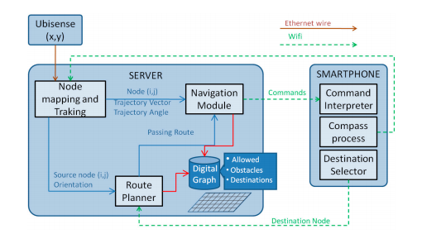

## Software Architecture

Guidance process to the next point of reference.

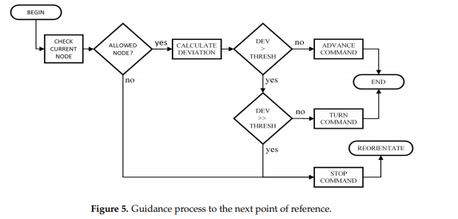

# Design Strategy

[Describe the design strategies or decisions that impact the overall organization of the system and its high-level structures. This information should provide the reader with insights into the key abstractions and mechanisms used in the system architecture.

For the strategy, discuss the reasoning employed (possibly referring to previously stated design goals and principles) and any trade-offs. Areas for consideration include:

* Future system extension or enhancement
* System reuse
* User interface paradigms
* Data management (storage, distribution, persistence)
* Concurrency and synchronization]

# Detailed System Design

## Database Design

### ER Diagram

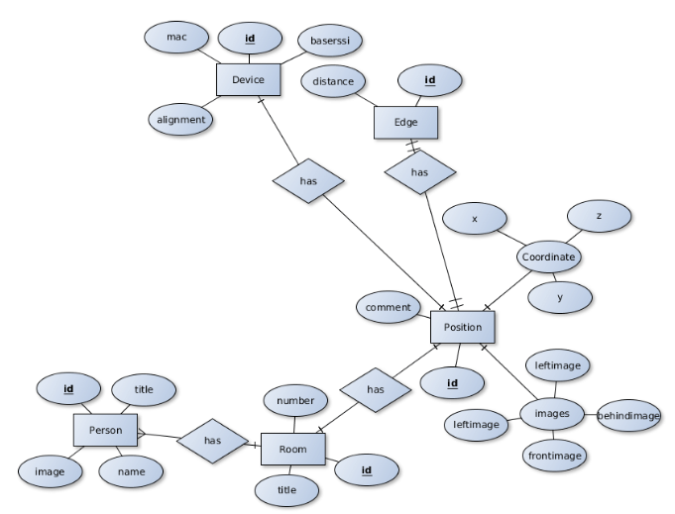

### Data Dictionary

#### Data 1

|  |  |  |  |  |  |  |  |
| --- | --- | --- | --- | --- | --- | --- | --- |
| < Data 1> | | | | | | | |
| **Name** | | Person | | | | | |
| **Alias** | | N/A | | | | | |
| **Where-used/how-used** | | The application will use the data as to keep record of the person using the app. | | | | | |
| **Content description** | | The Blind user details will be stored in this table. | | | | | |
|  | | | | | | | |
| **Column Name** | **Description** | | **Type** | **Length** | **Null able** | **Default Value** | **Key Type** |
| Id | Primary id | | integer | 5 | Not Nullable |  | PK |
| Name | Name of the blind | | String | 50 | Not Nullable | Unknown |  |
| Age | Age of the blind | | integer | 3 | Not Nullable | 30 |  |

#### Data 2

|  |  |  |  |  |  |  |  |
| --- | --- | --- | --- | --- | --- | --- | --- |
| < Data 2> | | | | | | | |
| **Name** | | Room | | | | | |
| **Alias** | | Checkpoints | | | | | |
| **Where-used/how-used** | | The application will use the data as to keep record of the checkpoints which will help in tracking the route. | | | | | |
| **Content description** | | The data for tracking the route will be stored in the table which will guide the user through different checkpoints. | | | | | |
|  | | | | | | | |
| **Column Name** | **Description** | | **Type** | **Length** | **Null able** | **Default Value** | **Key Type** |
| Id | Primary id | | integer | 5 | Not Nullable |  | PK |
| Title | Name of the checkpoint | | string | 5 | Not Nullable | Unknown |  |

.

#### Data 3

|  |  |  |  |  |  |  |  |
| --- | --- | --- | --- | --- | --- | --- | --- |
| < Data 3> | | | | | | | |
| **Name** | | Position | | | | | |
| **Alias** | | Current Positions | | | | | |
| **Where-used/how-used** | | The application will use the data for locating the current position of the blind which will help in guiding through its desired destination. | | | | | |
| **Content description** | | The data for tracking the current location will be stored in this table. | | | | | |
|  | | | | | | | |
| **Column Name** | **Description** | | **Type** | **Length** | **Null able** | **Default Value** | **Key Type** |
| Id | Primary id | | integer | 5 | Not Nullable |  | PK |
| Title | Name of the checkpoint | | String | 50 | Not Nullable | Unknown |  |
| x-coordinate | One of the coordinates | | double | 5 | Not Nullable | Unknown |  |
| y-coordinate | Other coordinate | | Double | 5 | Not Nullable | Unknown |  |
| z-coordinate | Other possible coordinate | | Double | 5 | Not Nullable | Unknown |  |
| Left Image | Surrounding image | | Blob | 1200 | Not Nullable | Unknown |  |
| Right image | Surrounding image | | Blob | 1200 | Not Nullable | Unknown |  |
| Upper image | Surrounding image | | Blob | 1200 | Not Nullable | Unknown |  |
| Lower image | Surrounding image | | Blob | 1200 | Not Nullable | Unknown |  |

#### Data 4

|  |  |  |  |  |  |  |  |
| --- | --- | --- | --- | --- | --- | --- | --- |
| < Data 4> | | | | | | | |
| **Name** | | Device | | | | | |
| **Alias** | | Operating device | | | | | |
| **Where-used/how-used** | | The application will be using the details of The device which is running this application. The details will be provided via following table. | | | | | |
| **Content description** | | Mac address and other information will be stored in the table. | | | | | |
|  | | | | | | | |
| **Column Name** | **Description** | | **Type** | **Length** | **Null able** | **Default Value** | **Key Type** |
| Id | Primary id | | integer | 5 | Not Nullable |  | PK |
| MAC | MAC Address of device | | String | 50 | Not Nullable | Unknown |  |

## Application Design

### Sequence Diagram

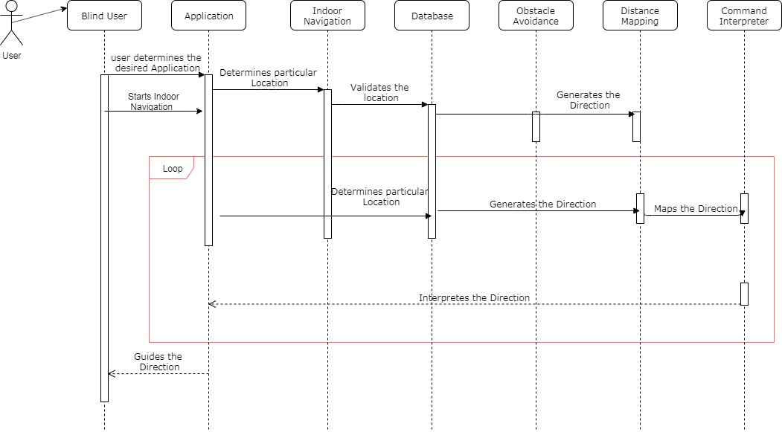

### State Diagram

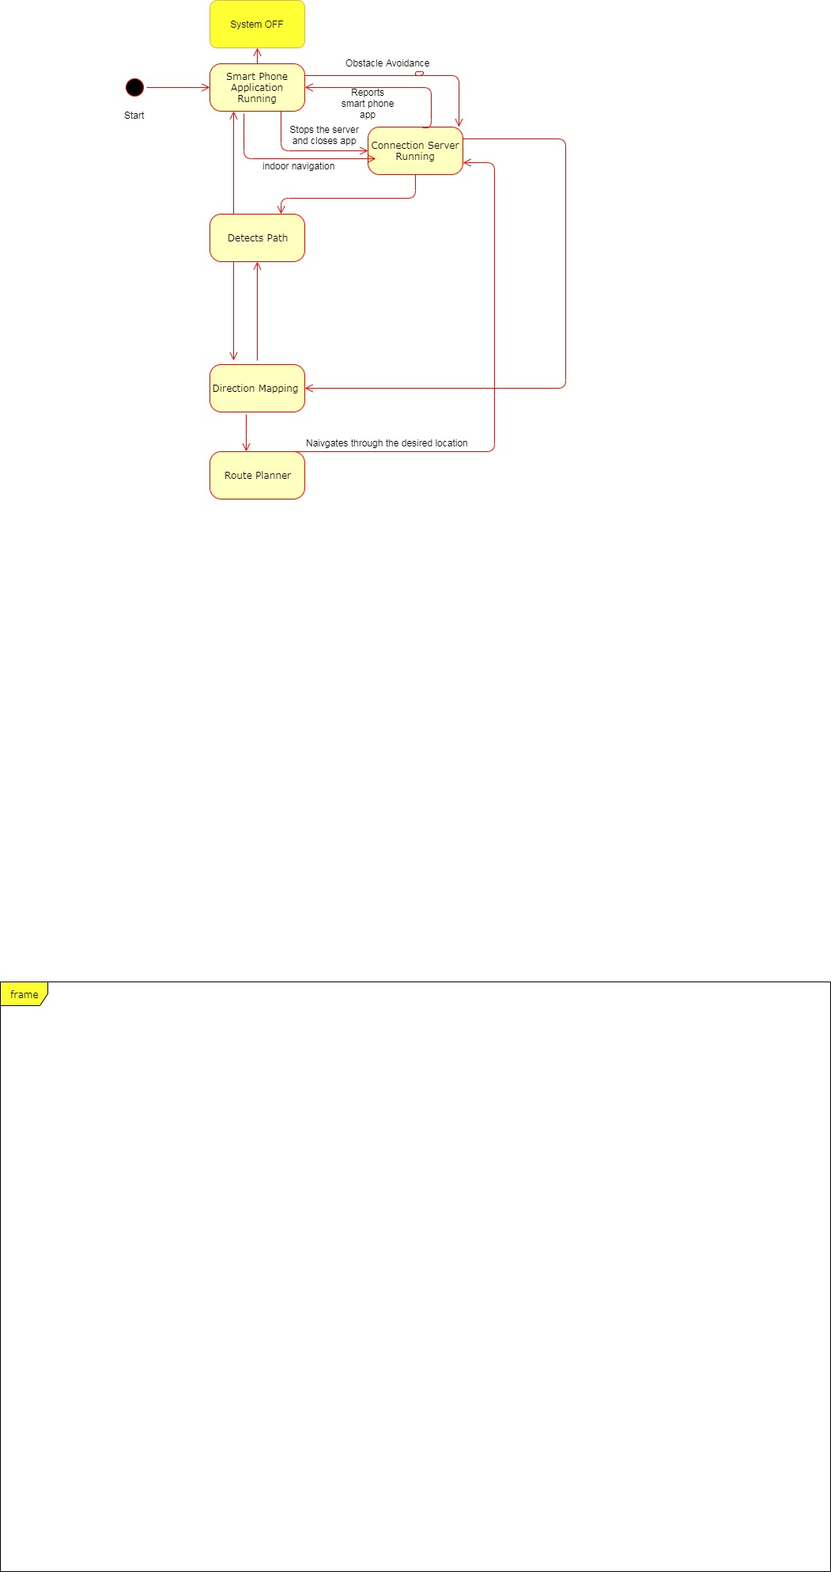

# References

NA

# Appendices

NA